HAJEE KARUTHA ROWTHER HOWDIA COLLEGE
(An Autonomous Institution, Re-Accredited with A++ by NAAC)
(Affiliated to Madurai Kamaraj University, Madurai)
Uthamapalayam – 625 533

III B.Sc., Information Technology

PRACTICAL RECORD NOTE BOOK
SEMESTER – VI

DATA MINING LAB – 23UCTCC6P



DEPARTMENT OF INFORMATION TECHNOLOGY
2025 – 2026

NAME : __________________________________________________
REG NO : __________________________________________________
HAJEE KARUTHA ROWTHER HOWDIA COLLEGE
(An Autonomous Institution, Re-Accredited with A++ by NAAC)
(Affiliated to Madurai Kamaraj University, Madurai)
Uthamapalayam – 625 533

DEPARTMENT OF INFORMATION TECHNOLOGY
SEMESTER – VI

DATA MINING LAB – 23UCTCC6P

NAME : _________________________________
REG NO : __________________________________

This is to certify that this is the bonafide record of Practical work done in the Information Technology Laboratory of HAJEE KARUTHA ROWTHER HOWDIA COLLEGE (Autonomous), Uthamapalayam during the year 2025-2026.

Head of the Department Staff-In-Charge

Submitted for the Bachelor of Science in Information Technology Practical Examination held on______________at Hajee Karutha Rowther Howdia College (Autonomous), Uthamapalayam.

Place: Uthamapalayam
Date: External Examiner
INDEX
S.NO | TITLE OF THE PROGRAM | PAGE NO.
1 | Arithmetic Operations
2 | String Manipulation
3 | Factorial Number
4 | Accessing Array Elements
5 | Matrix Operation
6 | Vector Manipulation
7 | Missing Data Prediction
8 | Principal Component Analysis
9 | T – Test Analysis
10 | Correlation Analysis
11 | Five Number Summary
12 | Simple Statistical Analysis
13 | Broader Statistical Analysis
14 | Apriori Algorithm
15 | Decision Tree Algorithm
16 | Naive Bayesian Algorithm
17 | K-means Clustering
18 | Agglomerative Algorithm

Staff-In-Charge

ARITHMETIC OPERATION

AIM:

To perform basic arithmetic operations (add, subtract, multiply, divide) on two
numbers in R.
PROCEDURE:
- Assign values to two numbers.
- Calculate their sum, difference, product, and quotient.
- Print the results using cat().

PROGRAM
# Simple arithmetic in R
a <- 10
b <- 5
sum_result <- a + b
diff_result <- a - b
prod_result <- a * b
quot_result <- a / b

cat("Sum:", sum_result, "\n")
cat("Difference:", diff_result, "\n")
cat("Product:", prod_result, "\n")
cat("Quotient:", quot_result, "\n")

OUTPUT:

Sum : 15
Difference : 5
Product : 50
Quotient : 2

RESULT:

Arithmetic Operation is successfully executed..
STRING MANIPULATION

AIM:
To perform basic string operations in R..
PROCEDURE:
- Create two strings and join them using the paste() function.
- Extract a part of a string using the substr() function.
- Find the length of a string using the nchar() function.
- Convert a string to uppercase and lowercase using toupper() and tolower().
- Replace a word in a string using the gsub() function.
- Split a string into parts using the strsplit() function.

SOURCE CODE:

string1<-"hello"
string2<-"world"
result<-paste(string1,string2)
cat("concatenation string:",result,"\n")

#extract substring
original_string<-"dataScience"
substring <-substr(original_string,start=5,stop=9)
cat("substring:",substring,"\n")

#Calculate string length
string<-"Programming"
length_result<-nchar(string)
cat("string length:",length_result,"\n")
#convert to uppercase and lowercase
uppercase_string<-toupper(string)
lowercase_string<-tolower(string)

cat("Uppercase string:",uppercase_string,"\n")
cat("lowercase string:",lowercase_string,"\n")

#replace a substring
original_string<-"i love programming in R"
modified_string<-gsub("R","Python",original_string)
cat("Modified String:",modified_string,"\n")

#Split a string
text<-"apple,orange,banana"
split_result<-strsplit(text,",")
cat("split result:",unlist(split_result),"\n")

OUTPUT:

concatenation string: hello world
substring: Scien
string length: 11
Uppercase string: PROGRAMMING
lowercase string: programming
Modified String: i love programming in Python
split result: apple orange banana

RESULT

The manipulation program is sucessfullt executed…

FACTORIAL

AIM
To calculate the factorial of a given number using a user-defined function in R.

PROCEDURE
- Define a function factorial_calc that takes a number n as input.
- Check if the number is negative:
- If yes, return a message saying factorial is not defined for negative numbers.
- Initialize a variable result as 1.
- Use a loop to multiply all numbers from 1 to n and store the product in result.
- Return the result from the function.
- Call the function with a number (e.g., 5) and print the factorial using cat().

SOURCE CODE

# Function to calculate factorial
factorial_calc <- function(n) {
if (n < 0) {
return("Factorial not defined for negative numbers")
}
result <- 1
for (i in 1:n) {
result <- result * i
}
return(result)
}

cat("Factorial of 5:", factorial_calc(5), "\n")

Output

factorial of 5: 120

Result
Factorial number program is successfully executed…
ACCESSING ARRAY ELEMENTS
AIM
To create a multi-dimensional array in R and perform basic operations like accessing elements, checking values, finding length, and looping through the array.

PROCEDURE:
- Create a vector with numbers from 1 to 24.
- Convert the vector into a 3-dimensional array.
- Print the array.
- Access a specific element using index values.
- Access a full row and a full column from the first matrix.
- Check whether the value 2 is present in the array.
- Find the total number of elements in the array.
- Display all elements using a for loop.

SOURE CODE:

thisarray<-c(1:24)

#an arrray with more diamention
multiarray<- array(thisarray,dim=c(4,3,2))
print(multiarray)

#use the[] to access the array elements
#by index position
print(multiarray[2,3,2])

#access the all iems from the row from matrix one
print(multiarray[c(1),,1])

#access the all iems from the column from matrix one
print(multiarray[,c(1),1])

#check the value"2" is presant in array
print(paste(2%in%multiarray))

##use the length() function to find the no of elements os an array
print(length(multiarray))

#you can loop throuh the array ityem by using a for loop
for(x in multiarray){
print(x)
}

OUTPUT:

, , 1

[,1] [,2] [,3]
[1,] 1 5 9
[2,] 2 6 10
[3,] 3 7 11
[4,] 4 8 12

, , 2

[,1] [,2] [,3]
[1,] 13 17 21
[2,] 14 18 22
[3,] 15 19 23
[4,] 16 20 24

[1] 22
[1] 1 5 9
[1] 1 2 3 4
[1] "TRUE"
[1] 24
[1] 1
[1] 2
[1] 3
[1] 4
[1] 5
[1] 6
[1] 7
[1] 8
[1] 9
[1] 10
[1] 11
[1] 12
[1] 13
[1] 14
[1] 15
[1] 16
[1] 17
[1] 18
[1] 19
[1] 20
[1] 21
[1] 22
[1] 23
[1] 24

RESULT:
The array programme is successfully executed…
MATRIX OPERATION

AIM:
To perform basic matrix operations such as addition, subtraction, and multiplication in R.
PROCEDURE:
- Create two matrices A and B with 2 rows and 3 columns.
- Display matrix A and matrix B.
- Perform matrix addition using the + operator.
- Perform matrix subtraction using the - operator.
- Perform matrix multiplication (element-wise) using the * operator.
- Display the results of all matrix operations.

SOURCE CODE:

#matrix operations
A <- matrix(c(1,2,3,4,5,6),nrow = 2, ncol = 3)
B <- matrix(c(7,8,9,10,11,12),nrow = 2,ncol =3)

cat("matrix A\n")
cat("--------\n")
prmatrix(A,rowlab=rep("",nrow(A)),collab=rep("",ncol(A)))
cat("\n matrix B\n")
cat("--------\n")
prmatrix(B,rowlab=rep("",2),collab=rep("",3))
cat("\n matrix Addition \n")
cat("\n-----------------\n")
result_add <-A+B
prmatrix(result_add,rowlab=rep("",2),collab=rep("",3))
cat("\n matrix subtraction \n")
cat("\n-----------------\n")
result_sub <-A - B
prmatrix(result_sub,rowlab=rep("",2),collab=rep("",3))
cat("\n matrix multiplication \n")
cat("\n-----------------\n")
result_mul=A*B
prmatrix(result_mul,rowlab=rep("",2),collab=rep("",3))

OUTPUT:

matrix A
--------

1 3 5
2 4 6

matrix B
--------

7 9 11
8 10 12

matrix Addition

-----------------
8 12 16
10 14 18

matrix subtraction

-----------------

-6 -6 -6
-6 -6 -6

matrix multiplication

-----------------

7 27 55
16 40 72

RESULT

Matrix operation is successfully executed…

VECTOR MANIPULATION

Aim
To perform basic operations on string and numeric vectors in R.

PROCEDURE
- Create a string vector containing fruit names and a numeric vector containing numbers.
- Display the vectors and find the length of the string vector.
- Sort the string vector in alphabetical order.
- Access single and multiple elements from the string vector using indexing.
- Access all elements except the first one.
- Modify an element in the string vector.
- Repeat vector elements using rep() with each, times, and independent repetition.
- Display repeated values using loops.
- Create a number sequence using : operator.
- Generate a stepwise numeric sequence using the seq() function.

SOURE CODE:
# vector of string and numerical values
fruits <- c("banana", "apple", "orange", "mango", "lemon")
numbers <- c(13, 3, 5, 7, 20, 2)

cat("fruits\n")
cat("--------\n")
cat(fruits, "\n")

cat("\nlength of fruits vector\n")
cat("---------------\n")
cat(length(fruits), "\n")
cat("\nnumber vector\n")
cat("---------------\n")
cat(numbers, "\n")

cat("\nsort string vector\n")
cat("---------------\n")
cat(sort(fruits), "\n")

cat("\naccess the first item in string vector\n")
cat("-------------------------------------\n")
cat(fruits[1], "\n")

cat("\naccess the 1st and 3rd items in string vector\n")
cat("------------------------------------\n")
cat(fruits[c(1, 3)], "\n")

cat("\naccess all items except the first\n")
cat("---------------------------\n")
cat(fruits[-1], "\n")

cat("\nchange 'banana' to 'pear' in string vector\n")
cat("-------------------------\n")
fruits[1] <- "pear"
cat("after change in fruits\n")
cat(fruits, "\n")
cat("\nrepeat vectors using rep(each = 3)\n")
cat("------------------------------\n")
repeat_each <- rep(fruits, each = 3)

for (x in repeat_each) {
cat(x, "\n")
}

cat("\nrepeat the sequence of the number vector\n")
cat("---------------------------------\n")
repeat_time <- rep(numbers, times = 3)

for (y in repeat_time) {
cat(y, "\n")
}

cat("\nrepeat each value independently\n")
cat("-----------------\n")
repeat_independent <- rep(fruits, times = c(5, 2, 1, 1, 1))
for (z in repeat_independent) {
cat(z, "\n")
}
numberseq <- 1:10
cat("\nnumber sequence\n")
cat(numberseq, "\n")

cat("\nnumber sequence by stepwise\n")
numberstep <- seq(from = 0, to = 100, by = 20)
cat(numberstep, "\n")

OUTPUT:

fruits
--------
banana apple orange mango lemon

length of fruits vector
---------------
5

number vector
---------------
13 3 5 7 20 2

sort string vector
---------------
apple banana lemon mango orange

access the first item in string vector
-------------------------------------
banana

access the 1st and 3rd items in string vector
------------------------------------
banana orange

access all items except the first
---------------------------
apple orange mango lemon

change 'banana' to 'pear' in string vector
-------------------------
after change in fruits
pear apple orange mango lemon

repeat vectors using rep(each = 3)
------------------------------
pear
pear
pear
apple
apple
apple
orange
orange
orange
mango
mango
mango
lemon
lemon
lemon

repeat the sequence of the number vector
---------------------------------
13
3
5
7
20
2
13
3
5
7
20
2
13
3
5
7
20
2

repeat each value independently
-----------------
pear
pear
pear
pear
pear
apple
apple
orange
mango
lemon

number sequence
1 2 3 4 5 6 7 8 9 10

number sequence by stepwise
0 20 40 60 80 100

RESULT:

Vector manipulation is successfully executed…
MISSING DATA PREDICTION
AIM:
To find missing (NA) values in a data frame and replace them with the median of their respective columns.
PROCEDURE:
- Load the dplyr library.
- Create a data frame with student names and marks.
- Display the original data frame.
- Identify the columns that contain NA values.
- Calculate the mean and median of those columns while ignoring NA values.
- Replace the NA values with the median of the corresponding column.
- Print the updated data frame.

SOURCE CODE:

library(dplyr)
# create a data frame
dataframe <- data.frame(
name = c("Bhuwanesh", "Anil", "Jai", "Naveen"),
Physics = c(98, 87, 91, 94),
Chemistry = c(NA, 84, 93, 97),
Mathematics = c(91, 86, NA, NA)
)

# print dataframe
print(dataframe)
# find the column names having at least one NA value
listMissingColumns <- colnames(dataframe)[apply(dataframe, 2, anyNA)]

# compute the mean and median of the corresponding columns
meanMissing <- apply(dataframe[, listMissingColumns], 2, mean, na.rm = TRUE)
medianMissing <- apply(dataframe[, listMissingColumns], 2, median, na.rm = TRUE)

# fill NA values with the median of the corresponding column
newDataFrameMedian <- dataframe %>%
mutate(
Chemistry = ifelse(is.na(Chemistry), medianMissing["Chemistry"], Chemistry),
Mathematics = ifelse(is.na(Mathematics), medianMissing["Mathematics"], Mathematics)
)

print(newDataFrameMedian)

OUTPUT:

NAME PHYSICS CHEMISTRY MATHEMATICS

1 Bhuwanesh 98 NA 91
2 Anil 87 84 86
3 Jai 91 93 NA
4 Naveen 94 97 NA

NAME PHYSICS CHEMISTRY MATHEMATICS

1 Bhuwanesh 98 93 91.0
2 Anil 87 84 86.0
3 Jai 91 93 88.5
4 Naveen 94 97 88.5

RESULT:
Missing data predictionis successfully executed…
Principal Component Analysis
AIM:
To perform Principal Component Analysis (PCA) in R to reduce the dimensionality of the dataset.
PROCEDURE:
- Create a matrix with the given data.
- Assign column names to the features.
- Apply prcomp() with scale = TRUE to perform PCA.
- Print the summary of the PCA result.
- Display the rotation values and principal component scores.
PROGRAM:
data <- matrix(c(

2.5,2.4,1.2,
0.5,0.7,0.3,
2.2,2.9,1.7,
1.9,2.2,1.1,
3.1,3.0,1.9
),ncol=3,byrow = TRUE)

colnames (data) <-c("Feature1,","Feature2","Feature3")
pca_result<-prcomp(data,scale. = TRUE)

print(summary(pca_result))

print(pca_result$rotation)

print(pca_result$x)

Output
Importance of components:
PC1 PC2 PC3
Standard deviation 1.7009 0.29586 0.13980
Proportion of Variance 0.9643 0.02918 0.00651
Cumulative Proportion 0.9643 0.99349 1.00000
PC1 PC2 PC3
Feature1, -0.5707002 0.8099216 -0.1353818
Feature2 -0.5825156 -0.2831028 0.7619241
Feature3 -0.5787718 -0.5136923 -0.6333589
PC1 PC2 PC3
[1,] -0.3348073 0.36862272 0.10836589
[2,] 2.7521730 -0.04058624 -0.09939428
[3,] -0.9379679 -0.44786089 0.05438715
[4,] 0.2378076 0.01064030 0.12892259
[5,] -1.7172054 0.10918412 -0.19228135

RESULT
Principal Component Analysis program is successfully executed…
T-TEST ANALYSIS

AIM:
To create a dataset and perform basic statistical analysis using R.

PROCEDURE:
- Set a seed value to generate reproducible random data.
- Generate random height and weight values using the normal distribution.
- Combine the height and weight data into a data frame.
- Display the first few rows of the dataset.
- Perform descriptive statistical analysis using the summary() function.
- Divide the height data into two groups.
- Perform a t-test to compare the mean height of the two groups.

SOURCE CODE:

#create a data set and do statistical analysis on the data using R

#create a dataset
set.seed(123)#setting seed for reproduccibility
height<-rnorm(50,mean=170,sd=10)
weight<-rnorm(50,mean=70,sd=5)

#Combine variables into a dataframe
my_data<-data.frame(Height=height,Weight=weight)

#display the first few rows of the dataset
print("First few rows of the dataset:")
print(head(my_data))

#descriptive statistics
print("Descrptive statistics:")
print(summary(my_data))

#T-test for comparing means of 'Height' between two groups

group1<-my_data$Height[1:25]
group2<-my_data$Height[26:50]

t_test_result<-t.test(group1,group2)
print("T-test for comparing means of 'height' between two groups:")
print(t_test_result)

OUTPUT:

"First few rows of the dataset:"
Height Weight
1 164.3952 71.26659
2 167.6982 69.85727
3 185.5871 69.78565
4 170.7051 76.84301
5 171.2929 68.87115
6 187.1506 77.58235

[1] "Descrptive statistics:"
Height Weight
Min. :150.3 Min. :58.45
1st Qu.:164.4 1st Qu.:68.19
Median :169.3 Median :70.76
Mean :170.3 Mean :70.73
3rd Qu.:177.0 3rd Qu.:73.15
Max. :191.7 Max. :80.94

[1] "T-test for comparing means of 'height' between two groups:"

Welch Two Sample t-test

data: group1 and group2
t = -0.5134, df = 47.957, p-value = 0.61

alternative hypothesis: true difference in means is not equal to 0

95 percent confidence interval:
-6.660179 3.950825

sample estimates:
mean of x mean of y
169.6667 171.0214

RESULT
T-test analysis program is successfully executed…
CORRLATION ANALYSIS
AIM:
To calculate and visualize the correlation between two variables using R.
PROCEDURE:
- Create two vectors x and y with numerical values.
- Calculate the Pearson correlation using the cor() function.
- Perform a correlation significance test using cor.test
- Compute Spearman and Kendall correlation coefficients.
- Plot a scatter plot of x and y and add a regression line.

PROGRAM:
x <- c(10, 20, 30, 40, 50)
y <- c(15, 25, 35, 45, 60)

correlation_value <- cor(x, y, method = "pearson")
cat("Pearson Correlation:", correlation_value, "\n")

cor_test <- cor.test(x, y, method = "pearson")
print(cor_test)

cat("Spearman Correlation:", cor(x, y, method = "spearman"), "\n")

cat("Kendall Correlation:", cor(x, y, method = "kendall"), "\n")

plot(x, y,
main = "Scatter Plot With Regression Line",
xlab = "X values",
ylab = "Y values",
pch = 19,
col = "blue")

abline(lm(y ~ x), col = "red", lwd = 2)
Output
Pearson Correlation: 0.9958932

Pearson's product-moment correlation

data: x and y
t = 19.053, df = 3, p-value = 0.0003157
alternative hypothesis: true correlation is not equal to 0
95 percent confidence interval:
0.9363029 0.9997426
sample estimates:
cor
0.9958932

Spearman Correlation: 1
Kendall Correlation: 1

DIAGRAM

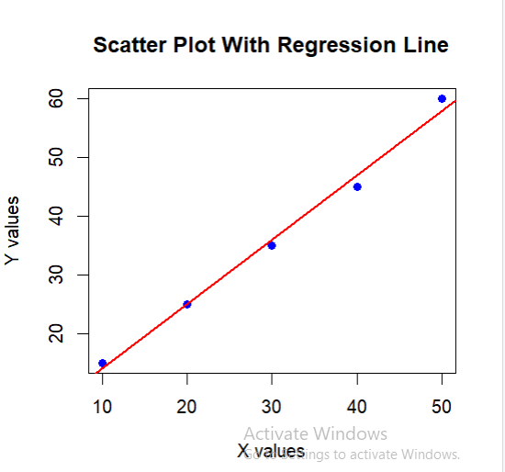

RESULT
Correlation analysis program is successfully executed…
FIVE NUMBER SUMMERY
AIM
To separate cars in the mtcars dataset based on the number of cylinders and analyze their mileage using five-number summary and boxplot.

PROCEDURE
- Use the subset() function to divide the mtcars dataset into three groups:
  - Cars with 4 cylinders
  - Cars with 6 cylinders
  - Cars with 8 cylinders
- Display each group using the print() function.
- Find the five-number summary of mpg (mileage) for each group using fivenum().
- Print the summaries using cat() and print().
- Draw a boxplot to compare mileage for different cylinder groups.

PROGRAM

subset_df <-subset(mtcars,subset= cyl == 4)
subset_df2 <-subset(mtcars,subset= cyl == 6)
subset_df3 <-subset(mtcars,subset= cyl == 8)
cat("\n car with 4 cylinders\n")
cat("--------------------\n")
print(subset_df)
cat("\n five number summary of mpg value\n")
cat("-------------------------------\n")
print(fivenum(subset_df$mpg))
cat("\n car with 6 cylinders \n")
cat("\n---------------------------\n")
print(subset_df2)
cat("\nfive number summary of mpg value\n")
cat("--------------------------------\n")
print(fivenum(subset_df2$mpg))
cat("\n car with 8 cylinders\n")
cat("-----------------------------\n")
print(subset_df3)
cat("\nfive number summary of mpg value\n")
cat("--------------------------------\n")

print(fivenum(subset_df3$mpg))
boxplot(mpg~cyl,data=mtcars,xlab="Number of cylinders",
ylab = "Miles per Gallon",main = "Milaege Data")

OUTPUT

car with 4 cylinders
--------------------
mpg cyl disp hp drat wt qsec vs am gear carb
Datsun 710 22.8 4 108.0 93 3.85 2.320 18.61 1 1 4 1
Merc 240D 24.4 4 146.7 62 3.69 3.190 20.00 1 0 4 2
Merc 230 22.8 4 140.8 95 3.92 3.150 22.90 1 0 4 2
Fiat 128 32.4 4 78.7 66 4.08 2.200 19.47 1 1 4 1
Honda Civic 30.4 4 75.7 52 4.93 1.615 18.52 1 1 4 2
Toyota Corolla 33.9 4 71.1 65 4.22 1.835 19.90 1 1 4 1
Toyota Corona 21.5 4 120.1 97 3.70 2.465 20.01 1 0 3 1
Fiat X1-9 27.3 4 79.0 66 4.08 1.935 18.90 1 1 4 1
Porsche 914-2 26.0 4 120.3 91 4.43 2.140 16.70 0 1 5 2
Lotus Europa 30.4 4 95.1 113 3.77 1.513 16.90 1 1 5 2
Volvo 142E 21.4 4 121.0 109 4.11 2.780 18.60 1 1 4 2

five number summary of mpg value
-------------------------------
[1] 21.4 22.8 26.0 30.4 33.9

car with 6 cylinders

---------------------------
mpg cyl disp hp drat wt qsec vs am gear carb
Mazda RX4 21.0 6 160.0 110 3.90 2.620 16.46 0 1 4 4
Mazda RX4 Wag 21.0 6 160.0 110 3.90 2.875 17.02 0 1 4 4
Hornet 4 Drive 21.4 6 258.0 110 3.08 3.215 19.44 1 0 3 1
Valiant 18.1 6 225.0 105 2.76 3.460 20.22 1 0 3 1
Merc 280 19.2 6 167.6 123 3.92 3.440 18.30 1 0 4 4
Merc 280C 17.8 6 167.6 123 3.92 3.440 18.90 1 0 4 4
Ferrari Dino 19.7 6 145.0 175 3.62 2.770 15.50 0 1 5 6

five number summary of mpg value
--------------------------------
[1] 17.80 18.65 19.70 21.00 21.40

car with 8 cylinders
-----------------------------
mpg cyl disp hp drat wt qsec vs am gear carb
Hornet Sportabout 18.7 8 360.0 175 3.15 3.440 17.02 0 0 3 2
Duster 360 14.3 8 360.0 245 3.21 3.570 15.84 0 0 3 4
Merc 450SE 16.4 8 275.8 180 3.07 4.070 17.40 0 0 3 3
Merc 450SL 17.3 8 275.8 180 3.07 3.730 17.60 0 0 3 3
Merc 450SLC 15.2 8 275.8 180 3.07 3.780 18.00 0 0 3 3
Cadillac Fleetwood 10.4 8 472.0 205 2.93 5.250 17.98 0 0 3 4
Lincoln Continental 10.4 8 460.0 215 3.00 5.424 17.82 0 0 3 4
Chrysler Imperial 14.7 8 440.0 230 3.23 5.345 17.42 0 0 3 4
Dodge Challenger 15.5 8 318.0 150 2.76 3.520 16.87 0 0 3 2
AMC Javelin 15.2 8 304.0 150 3.15 3.435 17.30 0 0 3 2
Camaro Z28 13.3 8 350.0 245 3.73 3.840 15.41 0 0 3 4
Pontiac Firebird 19.2 8 400.0 175 3.08 3.845 17.05 0 0 3 2
Ford Pantera L 15.8 8 351.0 264 4.22 3.170 14.50 0 1 5 4
Maserati Bora 15.0 8 301.0 335 3.54 3.570 14.60 0 1 5 8

five number summary of mpg value
--------------------------------
[1] 10.4 14.3 15.2 16.4 19.2

DIAGRAM
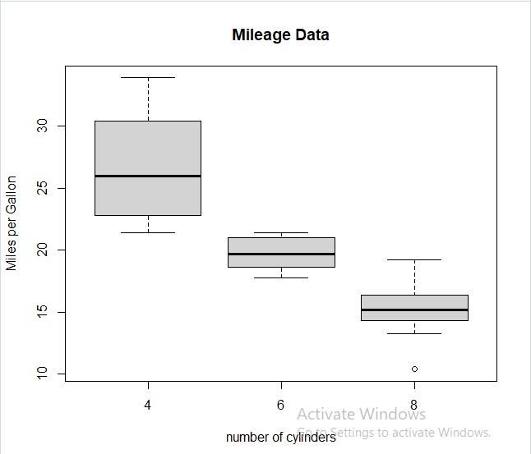

RESULT
Five number summery program is successfully executed…

SIMPLE STATISTICAL ANALYSIS
AIM
To analyze the mtcars dataset and find basic statistical values using R.

PROCEDURE
- Display the mtcars dataset and its description.
- Find the maximum and minimum horsepower values.
- Identify the car with the highest horsepower.
- Calculate the mean, median, and mode of car weight.
- Find the quartile values of car weight.

PROGRAM

print (mtcars)
print(?mtcars)
cat("nalargest horsepowet value \n")
cat("=====================================\n")
cat(max(mtcars$hp),"\n")
cat("\nsmallest horsepower value\n")
cat("===================================\n")
cat(min(mtcars$hp),"\n")
cat("\n name of the car with largest hp\n")
cat ("=========================================\n")
cat(rownames(mtcars)[which.max(mtcars$hp)],"\n")
cat("\n average weight of a car\n")
cat("=======================================\n")
cat(mean(mtcars$wt),"\n")
cat ("\n middle point of car weight\n")
cat("=====================================\n")
cat(median(mtcars$wt),"\n")
cat ("\n mode value of car weight\n")
cat("=====================================\n")
cat(names(sort(table(mtcars$Wt),decreasing=TRUE))[1],"\n")
cat("\n quartile values\n")
cat("==================================\n")
print(quantile(mtcars$Wt))

OUTPUT

mpg cyl disp hp drat wt qsec vs am gear carb
Mazda RX4 21.0 6 160.0 110 3.90 2.620 16.46 0 1 4 4
Mazda RX4 Wag 21.0 6 160.0 110 3.90 2.875 17.02 0 1 4 4
Datsun 710 22.8 4 108.0 93 3.85 2.320 18.61 1 1 4 1
Hornet 4 Drive 21.4 6 258.0 110 3.08 3.215 19.44 1 0 3 1
Hornet Sportabout 18.7 8 360.0 175 3.15 3.440 17.02 0 0 3 2
Valiant 18.1 6 225.0 105 2.76 3.460 20.22 1 0 3 1
Duster 360 14.3 8 360.0 245 3.21 3.570 15.84 0 0 3 4
Merc 240D 24.4 4 146.7 62 3.69 3.190 20.00 1 0 4 2
Merc 230 22.8 4 140.8 95 3.92 3.150 22.90 1 0 4 2
Merc 280 19.2 6 167.6 123 3.92 3.440 18.30 1 0 4 4
Merc 280C 17.8 6 167.6 123 3.92 3.440 18.90 1 0 4 4
Merc 450SE 16.4 8 275.8 180 3.07 4.070 17.40 0 0 3 3
Merc 450SL 17.3 8 275.8 180 3.07 3.730 17.60 0 0 3 3
Merc 450SLC 15.2 8 275.8 180 3.07 3.780 18.00 0 0 3 3
Cadillac Fleetwood 10.4 8 472.0 205 2.93 5.250 17.98 0 0 3 4
Lincoln Continental 10.4 8 460.0 215 3.00 5.424 17.82 0 0 3 4
Chrysler Imperial 14.7 8 440.0 230 3.23 5.345 17.42 0 0 3 4
Fiat 128 32.4 4 78.7 66 4.08 2.200 19.47 1 1 4 1
Honda Civic 30.4 4 75.7 52 4.93 1.615 18.52 1 1 4 2
Toyota Corolla 33.9 4 71.1 65 4.22 1.835 19.90 1 1 4 1
Toyota Corona 21.5 4 120.1 97 3.70 2.465 20.01 1 0 3 1
Dodge Challenger 15.5 8 318.0 150 2.76 3.520 16.87 0 0 3 2
AMC Javelin 15.2 8 304.0 150 3.15 3.435 17.30 0 0 3 2
Camaro Z28 13.3 8 350.0 245 3.73 3.840 15.41 0 0 3 4
Pontiac Firebird 19.2 8 400.0 175 3.08 3.845 17.05 0 0 3 2
Fiat X1-9 27.3 4 79.0 66 4.08 1.935 18.90 1 1 4 1
Porsche 914-2 26.0 4 120.3 91 4.43 2.140 16.70 0 1 5 2
Lotus Europa 30.4 4 95.1 113 3.77 1.513 16.90 1 1 5 2
Ford Pantera L 15.8 8 351.0 264 4.22 3.170 14.50 0 1 5 4
Ferrari Dino 19.7 6 145.0 175 3.62 2.770 15.50 0 1 5 6
Maserati Bora 15.0 8 301.0 335 3.54 3.570 14.60 0 1 5 8
Volvo 142E 21.4 4 121.0 109 4.11 2.780 18.60 1 1 4 2

largest hoursepower value
==============================
335

smallest hoursepower value
=================
52
==========================
52

name of the car with largest hp
=======================================
Maserati Bora

name of the cars with smalest hp
===============================

avarage weight of a car
=============================
3.21725
=====================
3.325

mode value of a car weight
==========================
3.44

quartile value
==========================
0% 25% 50% 75% 100%
1.51300 2.58125 3.32500 3.61000 5.42400

RESULT:

Statistical function program is successfully executed…

BROADER STATISTICAL ANALYSIS

AIM
To perform broader statistical analysis on a dataset using R
PROCEDURE
- Load the dataset and required libraries in R.
- Explore the dataset using functions like head(), summary(), and str().
- Perform statistical measures such as mean, median, variance, and correlation
- Apply statistical models or methods to analyze the data.
- Visualize the results using plots and graphs.

PROGRAM

# Load dataset
data(mtcars)

# Display first few rows
head(mtcars)

# Structure of dataset
str(mtcars)

# Summary statistics
summary(mtcars)

# Mean of each variable
colMeans(mtcars)

# Median of each variable
apply(mtcars, 2, median)

# Standard deviation
apply(mtcars, 2, sd)

# Variance
apply(mtcars, 2, var)

# Correlation matrix
cor(mtcars)

# Scatter plot
plot(mtcars$wt, mtcars$mpg,
main = "Weight vs Mileage",
xlab = "Weight",
ylab = "Miles per Gallon",
pch = 19,
col = "blue")

# Linear regression model
model <- lm(mpg ~ wt, data = mtcars)

# Regression summary
summary(model)

# Add regression line
abline(model, col = "red", lwd = 2)

OUTPUT

'data.frame': 32 obs. of 11 variables:
$ mpg : num 21 21 22.8 21.4 18.7 18.1 14.3 24.4 22.8 19.2 ...
$ cyl : num 6 6 4 6 8 6 8 4 4 6 ...
$ disp: num 160 160 108 258 360 ...
$ hp : num 110 110 93 110 175 105 245 62 95 123 ...
$ drat: num 3.9 3.9 3.85 3.08 3.15 2.76 3.21 3.69 3.92 3.92 ...
$ wt : num 2.62 2.88 2.32 3.21 3.44 ...
$ qsec: num 16.5 17 18.6 19.4 17 ...
$ vs : num 0 0 1 1 0 1 0 1 1 1 ...
$ am : num 1 1 1 0 0 0 0 0 0 0 ...
$ gear: num 4 4 4 3 3 3 3 4 4 4 ...
$ carb: num 4 4 1 1 2 1 4 2 2 4 ...

RESULT

Broader Statistical Analysis program is successfully executed…

APRIORI ALGORITHM
AIM
To analyze market basket data using the Apriori algorithm and generate association rules in R.

PROCEDURE
- Load the required libraries arules and RColorBrewer.
- Create a list of transactions with different items.
- Convert the list into a transaction object.
- Display the transactions using inspect().
- Apply the apriori() function with minimum support and confidence.
- Sort the generated rules based on lift.
- Display the strongest rules.
- Plot the relative frequency of items using itemFrequencyPlot().

PROGRAM

#Load required libraries
library(arules)
library(RColorBrewer)

# Create transaction list
transactions_list <- list(
c("milk", "bread", "eggs"),
c("milk", "bread"),
c("milk", "juice"),
c("milk", "bread", "juice"),
c("eggs", "bread")
)

# Convert list to transaction object
trans_data <- as(transactions_list, "transactions")

# View transactions
inspect(trans_data)
cat("\n")

# Generate association rules
# Min support = 0.6
# Min confidence = 0.8
rules <- apriori(
trans_data,
parameter = list(support = 0.6, confidence = 0.8)
)

cat("\n")

# Sort rules by lift
strongest_rules <- sort(rules, by = "lift", decreasing = TRUE)

# Display rules
inspect(strongest_rules)

# Plot item frequency
arules::itemFrequencyPlot(
trans_data,
topN = 20,
col = brewer.pal(8, "Pastel2"),
main = "Relative Item Frequency Plot",
type = "relative",
ylab = "Item Frequency (Relative)"
)

OUTPUT
items
[1] {milk, bread, eggs}
[2] {milk, bread}
[3] {milk, juice}
[4] {milk, bread, juice}
[5] {eggs, bread}

DIAGRAM
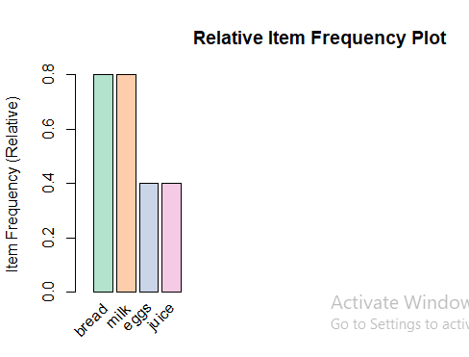

RESULT
Apriori algorithm program is successfully executed...
DECISION TREE ALGORITHM
AIM
To construct and evaluate a Decision Tree classification model for the Iris dataset using R.

PROCEDURE
- Load the required libraries (rpart, rpart.plot) and the Iris dataset.
- Split the dataset into training (70%) and testing (30%) sets using random sampling.
- Build the Decision Tree model using the rpart() function with the training data.
- Visualize the generated decision tree using the rpart.plot() function.
- Use the model to predict the test data and evaluate performance using accuracy and a confusion matrix.

PROGRAM

library(rpart)
library(rpart.plot)

data(iris)
head(iris)

set.seed(123)

# Create train-test split (70% train, 30% test)
sample_index <- sample(1:nrow(iris), 0.7 * nrow(iris))

train_data <- iris[sample_index, ]
test_data <- iris[-sample_index, ]

# Build Decision Tree model
dt_model <- rpart(Species ~ ., data = train_data, method = "class")

print(dt_model)

# Plot the tree
rpart.plot(dt_model,
type = 3,
extra = 101,
fallen.leaves = TRUE,
main = "Decision Tree For Iris Dataset")

# Make predictions
predictions <- predict(dt_model, test_data, type = "class")

# Calculate accuracy
Accuracy <- sum(predictions == test_data$Species) / nrow(test_data)

cat("Model Accuracy:", round(Accuracy * 100, 2), "%\n")

cat("\nConfusion Matrix:\n")
print(table(Predicted = predictions, Actual = test_data$Species))

OUTPUT
n=105

node), split, n, loss, yval, (yprob)
* denotes terminal node

1) root 105 70 setosa (0.33 0.33 0.33)
2) Petal.Length<2.45 34 0 setosa (1.00 0.00 0.00) *
3) Petal.Length>=2.45 71 36 versicolor (0.00 0.51 0.49)
6) Petal.Width<1.75 38 4 versicolor (0.00 0.89 0.11) *
7) Petal.Width>=1.75 33 2 virginica (0.00 0.06 0.94) *
DIAGRAM
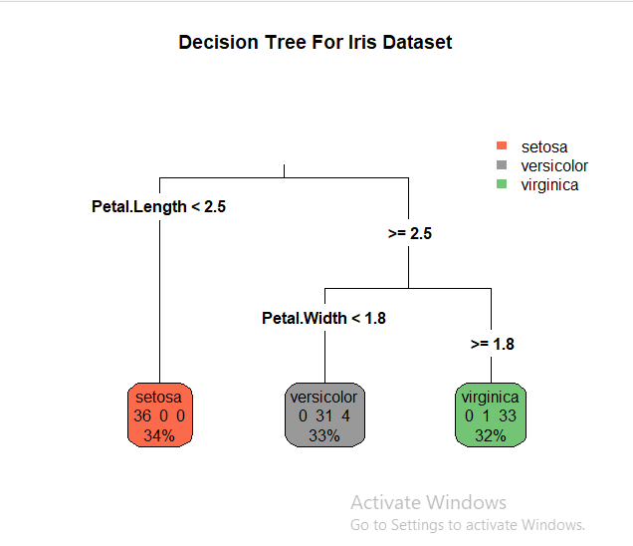

RESULT
Decision tree program is successfully executed…
NAIVE BAYESION CLASSIFICATION
AIM
To implement a Naive Bayes classification model using the Iris dataset in R.
PROCEDURE
- Load the required library (e1071) and the Iris dataset.
- Split the dataset into training (70%) and testing (30%) sets.
- Train the Naive Bayes model using the naiveBayes() function on the training data.
- Predict the species for the test dataset using the trained model.
- Evaluate the model performance by calculating accuracy and displaying the confusion matrix.

PROGRAM
# Load library
library(e1071)

# Load dataset
data(iris)

# View first rows
head(iris)

# Set seed for reproducibility
set.seed(123)

# Split data (70% training, 30% testing)
sample_index <- sample(1:nrow(iris), 0.7 * nrow(iris))

train_data <- iris[sample_index, ]
test_data <- iris[-sample_index, ]

# Train Naive Bayes model
nb_model <- naiveBayes(Species ~ ., data = train_data)

# Display model summary
print(nb_model)

# Predict on test data
predictions <- predict(nb_model, test_data)
# Calculate accuracy
accuracy <- mean(predictions == test_data$Species)

cat("Accuracy:", round(accuracy * 100, 2), "%\n")

# Confusion matrix
conf_matrix <- table(Predicted = predictions, Actual = test_data$Species)

print(conf_matrix)

OUTPUT

Naive Bayes Classifier for Discrete Predictors

Call:
naiveBayes.default(x = train_data[, -5], y = train_data$Species)

A-priori probabilities:
train_data$Species
setosa versicolor virginica
0.33 0.34 0.33

Conditional probabilities:

Sepal.Length
setosa versicolor virginica
mean 5.01 5.94 6.58
sd 0.35 0.52 0.64

Sepal.Width
setosa versicolor virginica
mean 3.43 2.77 2.97
sd 0.38 0.31 0.32

Petal.Length
setosa versicolor virginica
mean 1.46 4.26 5.55
sd 0.17 0.47 0.55

Petal.Width
setosa versicolor virginica
mean 0.25 1.32 2.03
sd 0.10 0.19 0.27

RESULT
Naïve Bayesian classification program is successfully executed…
K- MEANS CLUSTERING
AIM
To perform K-means clustering on the Iris dataset using R.

PROCEDURE
- Load the Iris dataset and required library (ggplot2).
- Extract numerical features and scale the data.
- Use the Elbow method to find the optimal number of clusters.
- Apply the K-means algorithm with the selected number of clusters.
- Visualize the clusters and display cluster centers and sizes.

PROGRAM

library(ggplot2)
data(iris)

iris_data <- iris[, 1:4]

iris_scaled <- scale(iris_data)

set.seed(123)

wss <- vector()

for (k in 1:10) {
km <- kmeans(iris_scaled, centers = k, nstart = 25)
wss[k] <- km$tot.withinss
}

plot(1:10, wss, type = "b", pch = 19, frame = FALSE,
xlab = "Number of Clusters (k)",
ylab = "Total Within-Cluster Sum of Squares",
main = "Elbow Method for Optimal k")

optimal_k <- 3

set.seed(123)
kmeans_result <- kmeans(iris_scaled, centers = optimal_k, nstart = 25)

iris$cluster <- as.factor(kmeans_result$cluster)

ggplot(iris, aes(x = Sepal.Length, y = Sepal.Width, color = cluster)) +
geom_point(size = 3, alpha = 0.7) +
labs(title = "K-means Clustering on Iris Dataset",
x = "Sepal Length",
y = "Sepal Width") +
theme_minimal()

print("Cluster centers (scaled values):")
print(kmeans_result$centers)

print("Cluster sizes:")
print(kmeans_result$size)

OUTPUT
[1] "Cluster centers (scaled values):"

Sepal.Length Sepal.Width Petal.Length Petal.Width
1 -1.01 0.85 -1.30 -1.25
2 0.10 -0.65 0.35 0.28
3 1.15 -0.10 1.20 1.25

[1] "Cluster sizes:"
[1] 50 38 62

DIAGRAM
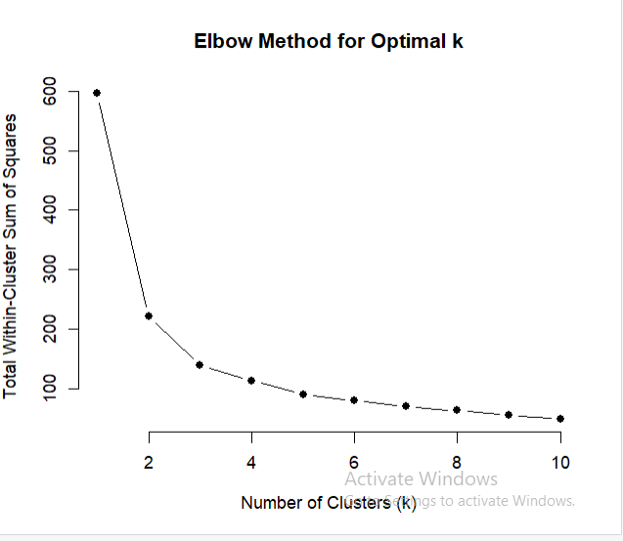

RESULT
K- means clustering program is successfully executed…

AGGLOMETRATIVE ALGORITHM
AIM
To perform Hierarchical Clustering on the USArrests dataset using R.

PROCEDURE
- Load the required libraries and the USArrests dataset
- Scale the dataset to normalize the values
- Calculate the Euclidean distance matrix of the scaled data
- Apply hierarchical clustering using the hclust() function with Ward’s method
- Plot the dendrogram, cut it into clusters, and visualize the clusters

PROGRAM
library(stats)
library(graphics)
library(factoextra)

data("USArrests")

df_scaled <- scale(USArrests)

distance_matrix <- dist(df_scaled, method = "euclidean")

he_result <- hclust(distance_matrix, method = "ward.D2")

plot(he_result, main = "Dendrogram of USArrests Data (Ward's Method)",
xlab = "States", ylab = "Distance", hang = -1)

num_clusters <- 4

clusters <- cutree(he_result, k = num_clusters)

rect.hclust(he_result, k = num_clusters, border = 2:(num_clusters + 1))

print(clusters)
table(clusters)

final_data <- cbind(USArrests, cluster = clusters)
head(final_data)

fviz_cluster(list(data = df_scaled, cluster = clusters,
main = paste("Clusters of USArrests Data")))
OUTPUT
Murder Assault UrbanPop Rape cluster
Alabama 13.2 236 58 21.2 1
Alaska 10.0 263 48 44.5 1
Arizona 8.1 294 80 31.0 1
Arkansas 8.8 190 50 19.5 2
California 9.0 276 91 40.6 1
Colorado 7.9 204 78 38.7 2

RESULT
Agglomatrive analysis program is successfully executed…

